

**FPT ACADEMY INTERNATIONAL**

**FPT – APTECH COMPUTER EDUCATION**

**USER GUIDE FOR PRIME FITNESS WEBSITE**

**I. System Requirement**

|  |  |  |
| --- | --- | --- |
| **No** | **Software** | **Description** |
| **1** | **Operating system** | **Windows 7 or higher** |
| **2** | **Hardware** | **Intel Pentium 4 processor or higher**  **512 Megabytes of RAM or higher** |
| **3** | **Software** | **Visual Studio Code, Dreamweaver** |
| **4** | **Web browser** | **Internet Explorer 11 , Chrome, Firefox** |

1. **Introduction and website installation**

- This document is created to guide users use the website – Prime Fitness effectively. It is advisable that users should read this document before starting to use this website in reality.

- To run *Prime Fitness* website, users need to do the following steps:

* + - 1. Download the file rar *eProject – Prime Fitness by Group 2 (FPT Aptech HCM)* via this link:
      2. Extract the file rar: *eProject – Prime Fitness by Group 2 (FPT Aptech HCM)*

1. Open the folder *eProject*
2. Open *index.html* file to start the website. Look at figure 1 for illustration
3. 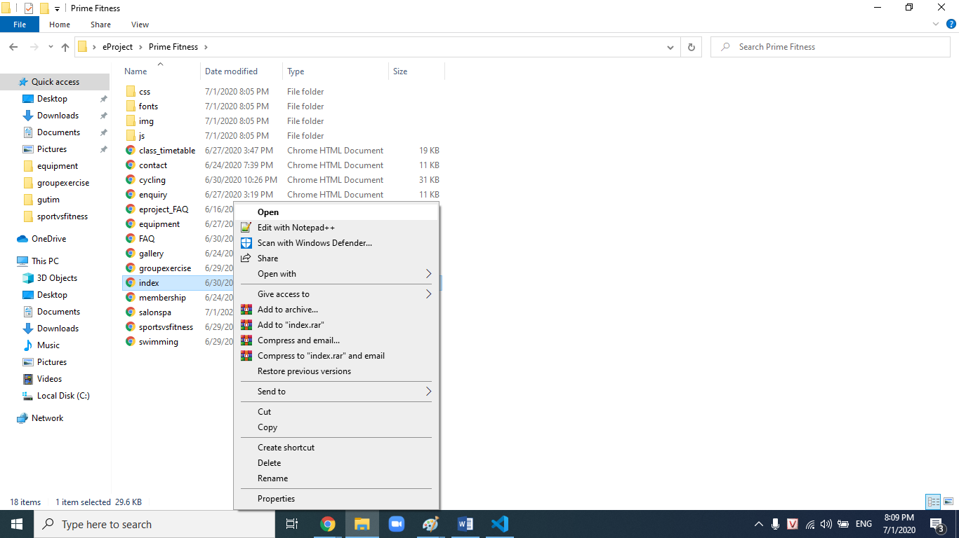

*Figure 1*

1. If done successfully, users will see the Homepage like figure 2 below
2. 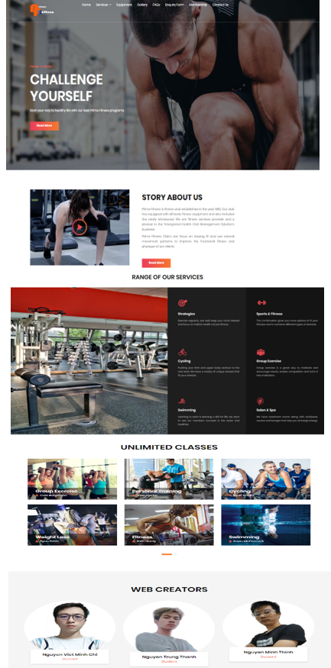

*Figure 2*

1. **Services page**

- This webpage displays information about the cycling, swimming, sports & fitness, group exercise and salon & spa. Users can review information from their favorite classes and sort class timetable on website by clicking on All gallery, Cycling, Swimming, Sports & Fitness, Group Exercise. Moreover, users can conduct a free 7-day trial on the registration form. For example, figure 3 and figure 4 illustrates how to register and sort class timetable.

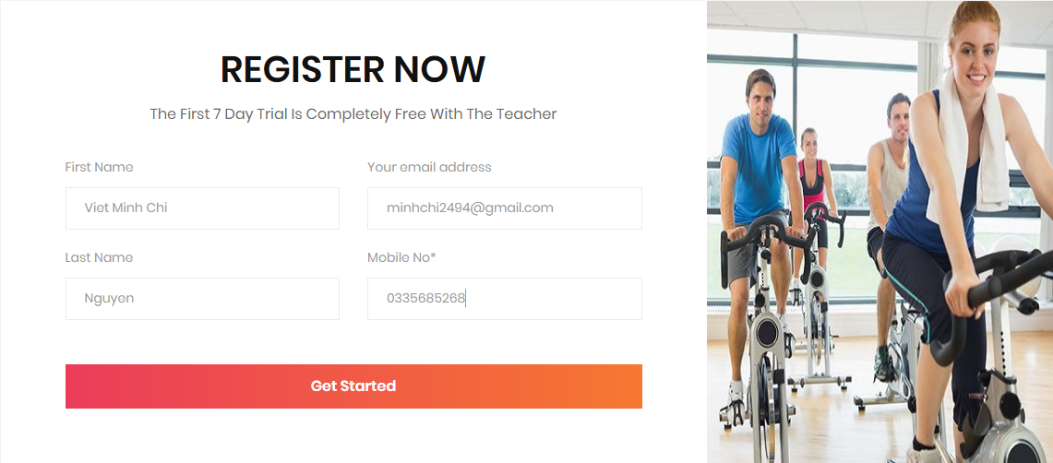

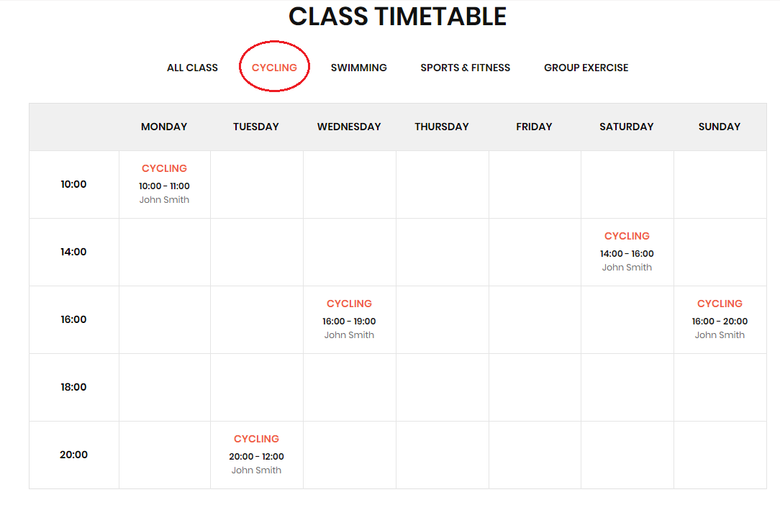

*Figure 3*

*Figure 4*

1. **Equipment page**

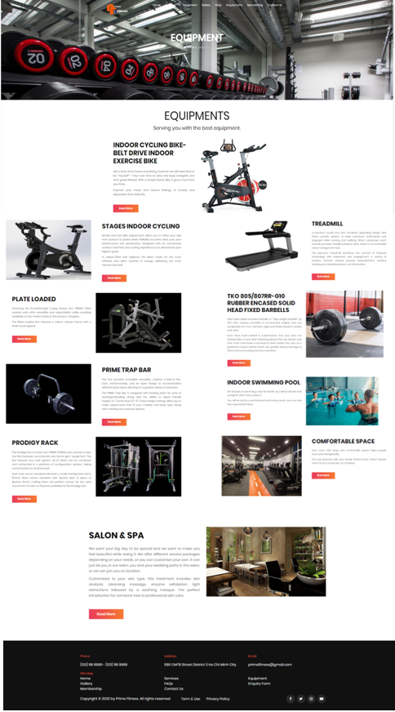- This webpage displays information about equipment and amenities at Prime Fitness Club. Users will have more detailed information about the type of equipment and training space. Look at figure 5 for illustration.

*Figure 5*

1. **Gallery page**

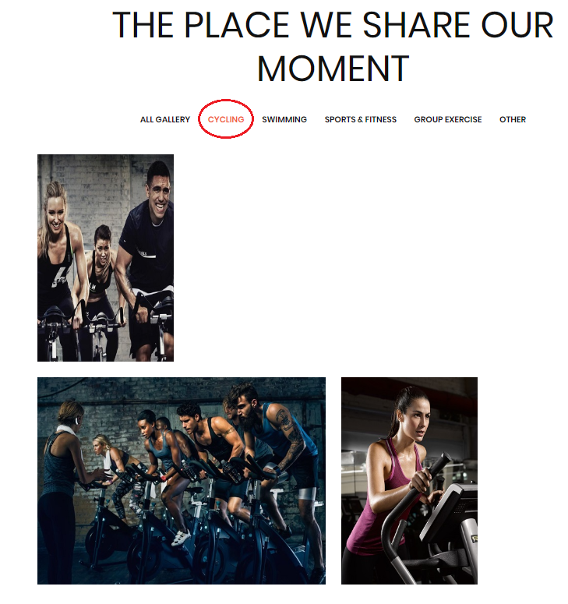- This webpage displays pictures of members practicing at Prime Fitness Club. Users can filter images for each topic by clicking on All gallery, Cycling, Swimming, Sports & Fitness, Group Exercise or Other. For example, figure 6 illustrates how to filter pictures.

*Figure 6*

1. **FAQs page**

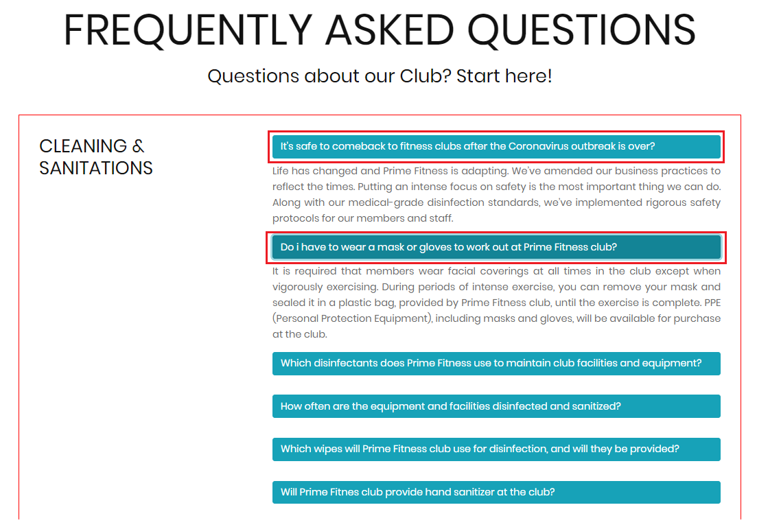- This webpage displays frequently asked questions. Users can find questions by each general topic. If the users want to see the answer of a specific question, they will click on the question and the answer will be displayed. For example, figure 7 illustrates how to display the answer.

*Figure 7*

1. **Enquiry Form page**

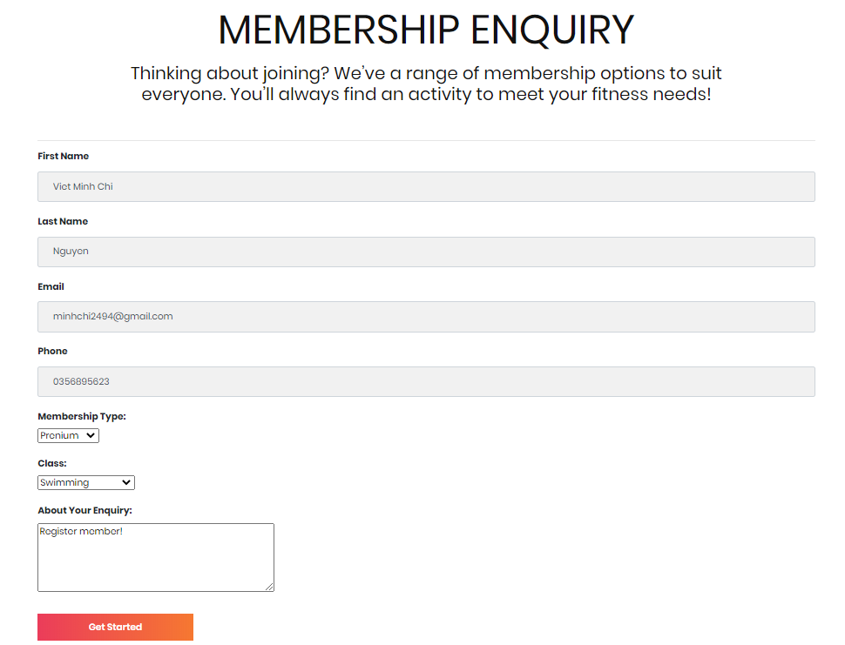- This webpage allows users register to become members of the club. Allow users to fill in personal information, register for classes, select membership types and send requests to the club. Look at figure 8 for illustration.

*Figure 8*

1. **Membership page**

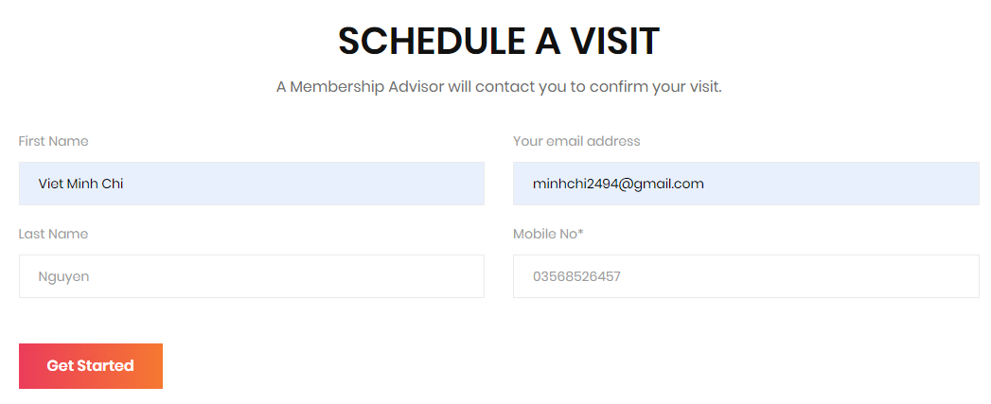- This webpage displays the benefits of being a member of the club. Allow users to fill in personal information to book an appointment before coming to the club and find the class timetable in unlimited class when users click “class schedule”. For example, figure 9, figure 10 and figure 11 illustrates how to book an appointment and show the class timetable.

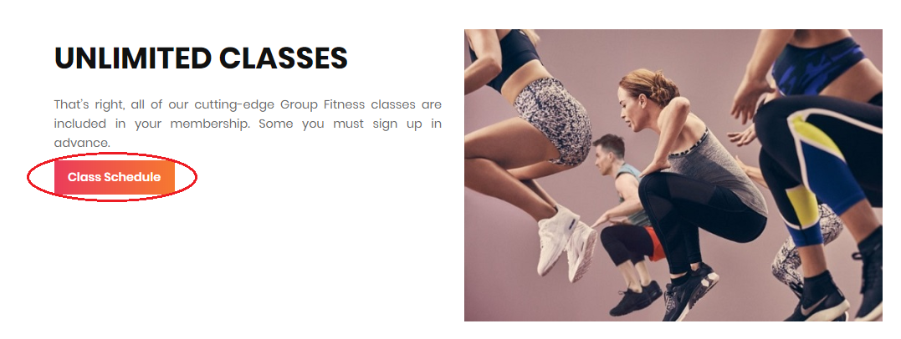

*Figure 9*

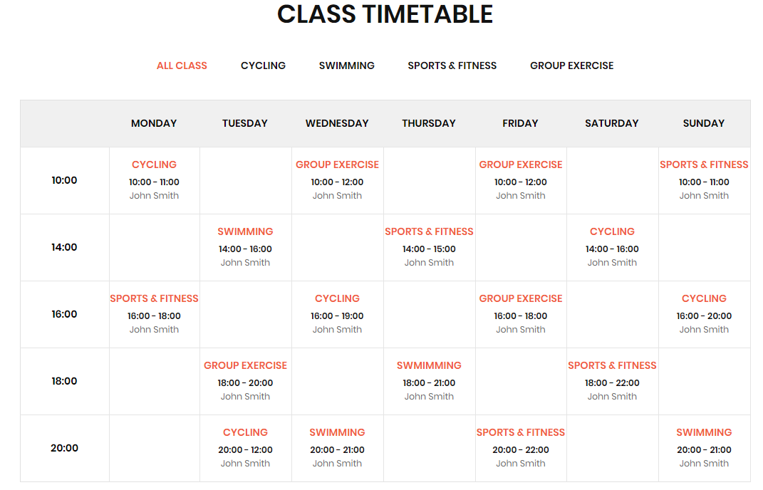

*Figure 11*

*Figure 10*

1. **Contact Us page**

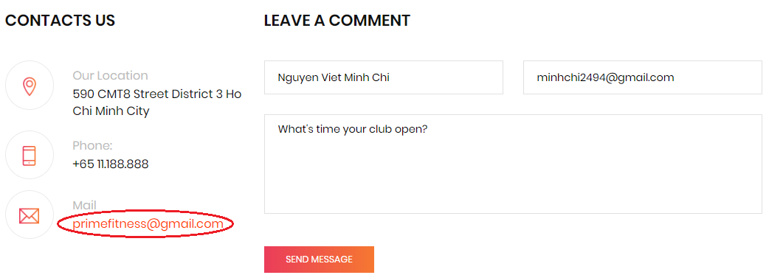This webpage allows users to request information they inquire to Prime Fitness club, open local mail by clicking email address and displays the geo location of the club. For example, figure 12 and figure 13 illustrates how to inquire to Prime Fitness club and open local mail.

*Figure 12*

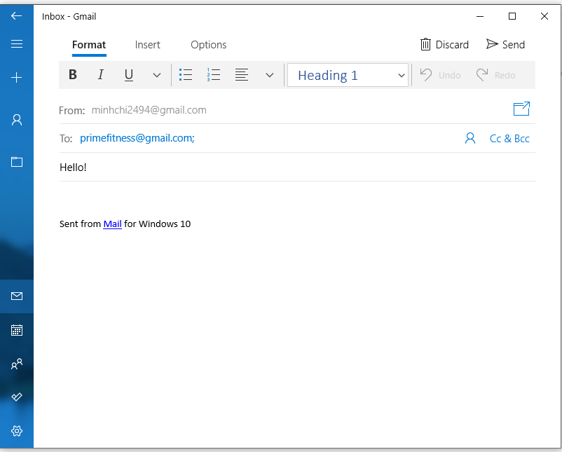

*Figure 13*